IAPA TELANGANA STATE BRANCH - Annual report : January - December 2022

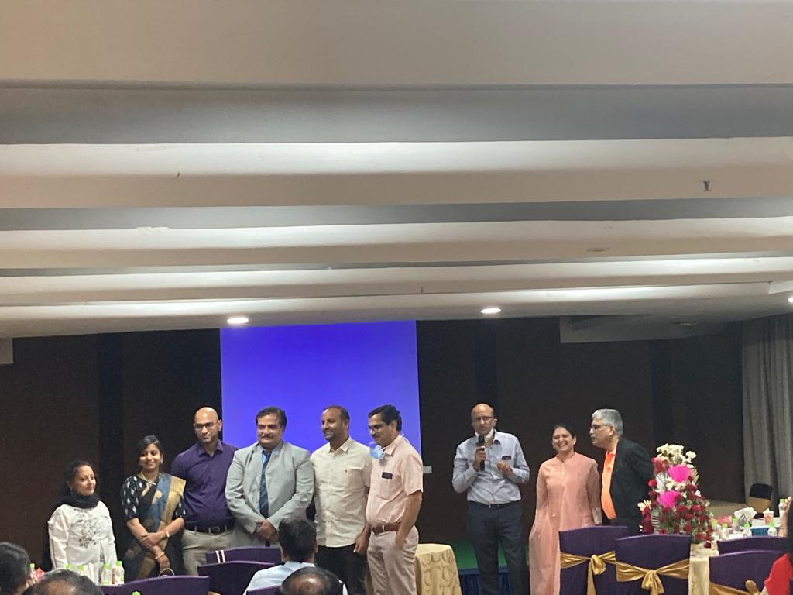
IAPA -TS being one of the first state branches under IAPA, has been very active in the academic front. As decided, during its conception, we have regularly been conducting scientific sessions once every 2 months involving premium institutes practising paediatric anaesthesia which include Niloufer hospital, Rainbow Children’s hospitals, Basavatarakam Indo American Cancer hospital, LV Prasad Eye Institute and many other enthusiasts of this speciality. These bimonthly meets were definitely an academic feast attended well by postgraduates, senior residents, junior and senior paediatric anaesthesia consultants. These half day programs brought about good interaction and exchange of knowledge and techniques among the attendees with pearls of wisdom transferred from the experienced senior stalwarts.

The academic and governing activities held were as follows-

15/03/2022 - Held at The Plaza Hotel
Guest lecture - Child with congenital heart disease posted for non cardiac surgery by Dr. B. Srinivas Reddy, Consultant, Malla Reddy Narayana hospital
Case presentations - 4 from different paediatric institutes
GBM - Felicitation of outgoing President : Dr. Gita Nath and Vice President : Dr. Damodhar Rao M
- Welcoming unanimously elected President : Dr. P.V. Shiva, Vice President : Dr. N. Srinivas Reddy, Executive committee members : Dr. Saritha Kumari, Dr. Srikanth MVN, Dr. Shiva Krishna Sampathi and Dr. Shwetha Ambati.

13/05/2022 - Held at The Plaza Hotel
Guest lecture - Anaesthetic implications in children with haematological malignancies by Dr. Vibhavari Naik, Consultant, Basavatarakam Indo American Cancer hospital.
Case presentations - 4 from different paediatric institutes

22/07/2023 - Held at Blue Fox Hotel
Guest lecture - TIVA in Paediatrics by Dr. Aanchal, Consultant, Basavatarakam Indo American Cancer hospital.
Guest lecture - Safe paediatric anaesthesia in remote locations by Dr. Raja Narsing Rao, Consultant, LV Prasad Eye hospital.
Case presentations - 2 from different paediatric institutes.
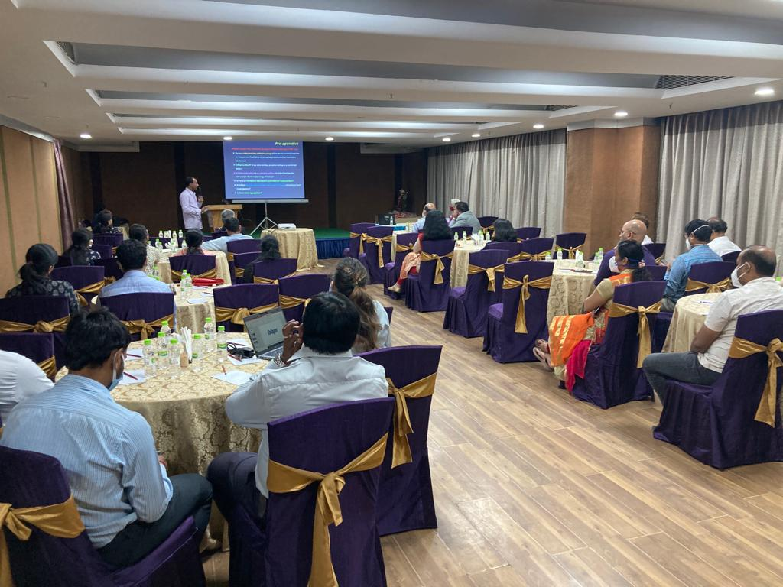
GBM - Felicitation of outgoing Secretrary : Dr. Ravi Naga Prasad, Treasurer : Dr.Sunidhara Reddy P, and Executive committee member : Dr. Raja Narsing Rao
- Welcoming unanimously elected Secretary : Dr. Sunidhara Reddy P. , Treasurer : Dr. Sailaja K, and Executive committee member : Dr. Sai Bhargavi Panchangam.

21/09/2022 - Held at Niloufer hospital
Guest lecture - Extension of Anaesthesiologist role in perinatal neonatal resuscitation by Dr. Aditya Kabra, Consultant, Pulse health care associates, HOD anaesthesia and critical care.
Case presentations - 4 from different paediatric institutes.
GBM - Handing over proceedings and accounts from past secretary and treasurer to the newly elected ones, Drive to increase the number of memberships to IAPA.

21/11/2022 - Held at LV Prasad Eye Institute
Guest lecture - Anaesthesia for Laparoscopy in paediatrics by Dr. Srikanth MVN, Consultant, EMRI Hospitals, Director - Pulse Health Care Associates.
Case presentations
- Anaesthetic Management of paediatric patient posted for Ventriculo-Pleural shunt by Dr. Anupama and Dr. Suneetha, ESI hospital
- Anaesthetic Management of Oesophageal duplication cyst ( posterior mediastinal tumour) by Dr. Hymavathi, Niloufer hospital
- Anaesthetic Management in paediatric baby with Ichthyosis by Dr. Charan and Dr. Dilshaad, LV Prasad Eye Institute.
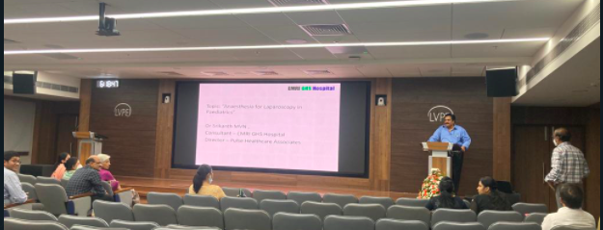
GBM - Compilation of the IAPA membership numbers, Planning to conduct one day CME program with workshop in the upcoming months by IAPA-TS.

IAPA Membership
The membership drive for IAPA has been the topmost priority of IAPA - TS to increase the number of our tribe so as to improve the safe practices in paediatric anaesthesia and to spread our wings to wider horizons. At present there are 85 IAPA members from Telangana state, out of which 5 have been added in the last year. The strive to increase the number will be ongoing.

The governing body of IAPA - TS hopes to work actively to continue the academic activities in form of bimonthly meets, workshops and CMEs in the future too.

